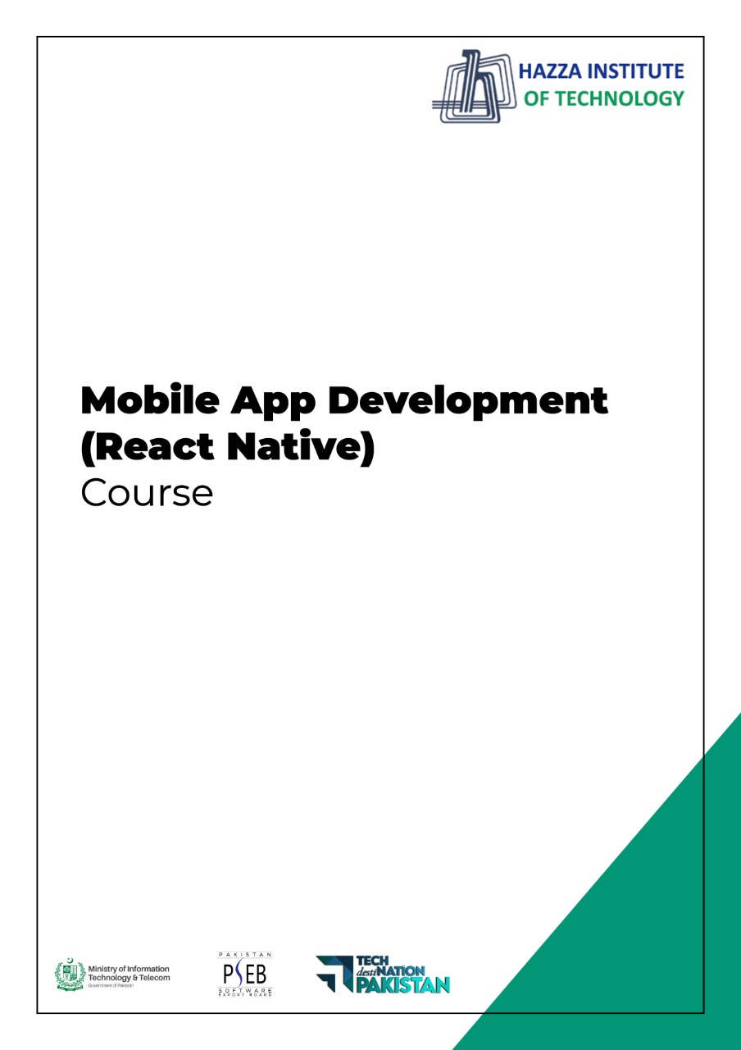

**(Flutter)**

Flutter Lab 7 (Session 1)

**Total Time:**

**3 hours (sessions-1)**

**Pre-Lab Activities:**

* + Student must complete previous labs

**Learning Outcomes:**

* Demonstrate the knowledge of Flutter to design stateful, cross-platform, and interactive user interfaces for mobile applications.
* In this lab we will be reviewing Stateful and Stateless Widgets as well as learning about the fundamental building blocks of Object-Oriented Programming (OOP) - Classes and Objects.

**Student Activities:**

* + Practicing Stateless and Statfull Widgets

**Lab Tasks:**

* + Create a Flutter UI accoridng to below figure

We’re going to make a quiz app that tests your general knowledge. As one of the most popular types of apps on the app stores, you can create your own quiz for other people to enjoy!

Therefore, you are required to develop the Quiz app (as given in Figure 1) by following the steps.

1. Create a class “Question” that has two data members (i.e., question and answer).
2. Create a class “QuestionBank” that has 10 objects of the “Question” class which adds appropriate questions and answers. Further, this class must have an identifier that locates the current question being displayed on the screen. Furthermore, create a method “nextQuestion” to display the next question on the screen.
3. Display the question, and score on the screen as given the Figure 1. Further, appropriately update the scorekeeper. However, your app must not show more than 10 (maximum number of questions in QuestionBank.



**Lab Solutions:**

**CODE:**

|  |
| --- |
| import 'package:flutter/material.dart';  void main() => runApp(Quizzler());  class Quizzler extends StatelessWidget {  @override  Widget build(BuildContext context) {  return MaterialApp(  home: Scaffold(  backgroundColor: Colors.grey.shade900,  body: SafeArea(  child: Padding(  padding: EdgeInsets.symmetric(horizontal: 10.0),  child: QuizPage(),  ),  ),  ),  );  }  }  class QuizPage extends StatefulWidget {  @override  _QuizPageState createState() => _QuizPageState();  }  class _QuizPageState extends State<QuizPage> {  @override  Widget build(BuildContext context) {  return Column(  mainAxisAlignment: MainAxisAlignment.spaceBetween,  crossAxisAlignment: CrossAxisAlignment.stretch,  children: <Widget>[  Expanded(  flex: 5,  child: Padding(  padding: EdgeInsets.all(10.0),  child: Center(  child: Text(  'This is where the question text will go.',  textAlign: TextAlign.center,  style: TextStyle(  fontSize: 25.0,  color: Colors.white,  ),  ),  ),  ),  ),  Expanded(  child: Padding(  padding: EdgeInsets.all(15.0),  child: FlatButton(  textColor: Colors.white,  color: Colors.green,  child: Text(  'True',  style: TextStyle(  color: Colors.white,  fontSize: 20.0,  ),  ),  onPressed: () {  //The user picked true.  },  ),  ),  ),  Expanded(  child: Padding(  padding: EdgeInsets.all(15.0),  child: FlatButton(  color: Colors.red,  child: Text(  'False',  style: TextStyle(  fontSize: 20.0,  color: Colors.white,  ),  ),  onPressed: () {  //The user picked false.  },  ),  ),  ),  //TODO: Add a Row here as your score keeper  ],  );  }  }  /*  question1: 'You can lead a cow down stairs but not up stairs.', false,  question2: 'Approximately one quarter of human bones are in the feet.', true,  question3: 'A slug\'s blood is green.', true,*/ |